Exp no:10 Implement Boundary condition between two different dielectric medium in Magnetic Field and find the relative permeability of the different medium.
Aim: To write program for Boundary condition between two different dielectric media in magnetic field using SCILAB.
Software required: •SCILAB version 6.0.1
Theory: When a magnetic field is present at the boundary between two different dielectric media (or magnetic materials), boundary conditions govern how the magnetic field behaves as it crosses from one medium to the other. These boundary conditions arise from Maxwell's equations and the properties of the materials involved, such as relative permeability, μr, which governs the material's response to the magnetic field.
Coding:
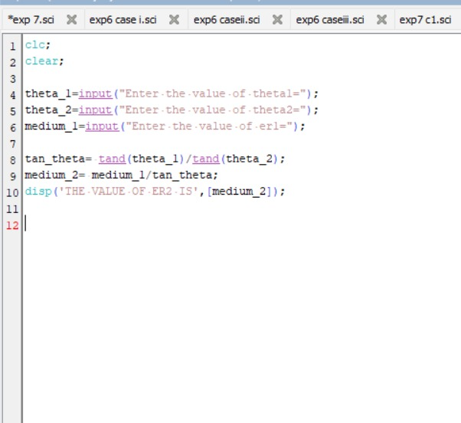
Calculation:
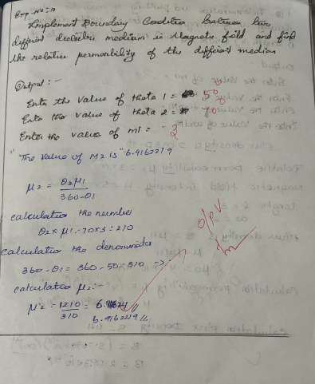

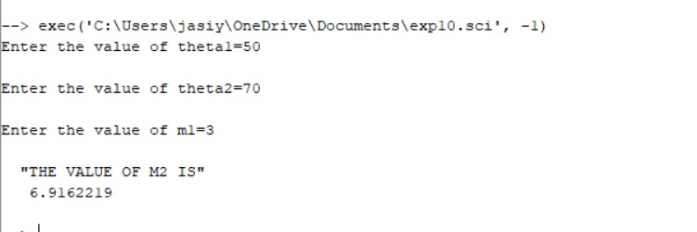
Output:

Case 1: Consider two identical media in the presence of a magnetic field. The relative permeability in both media is 1. What will be the effect of this on the magnetic field and flux density across the boundary?
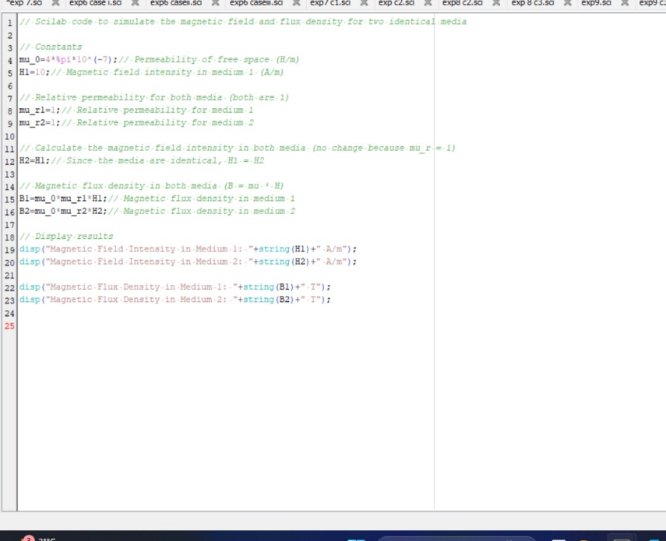
Output:
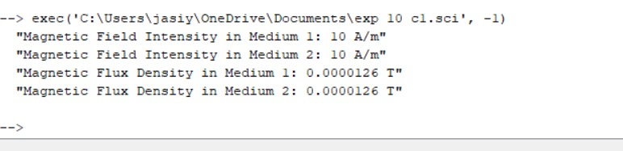
Case 2: In a system with two media, where the relative permeability of medium 1 is μr1=4 and medium 2 is a vacuum (μr2=1), how would the magnetic field intensity and flux density behave at the boundary?
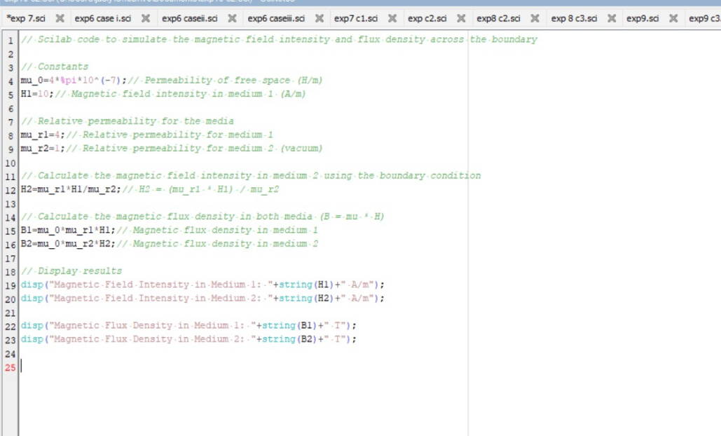
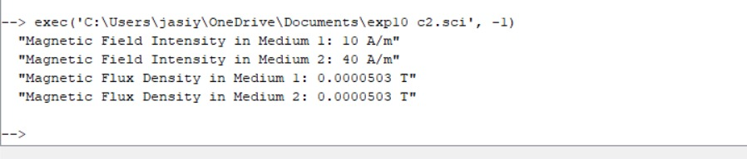
Case 3: If medium 1 has a relative permeability μr1=0.3 and medium 2 has a relative permeability μr2=2, calculate the magnetic field intensity in both media at the boundary if the magnetic field intensity in medium 1 is known to be H1=10 A/m.
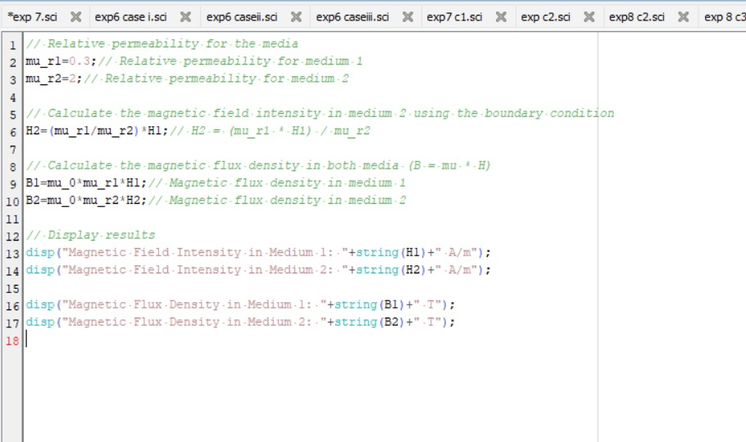
Output:
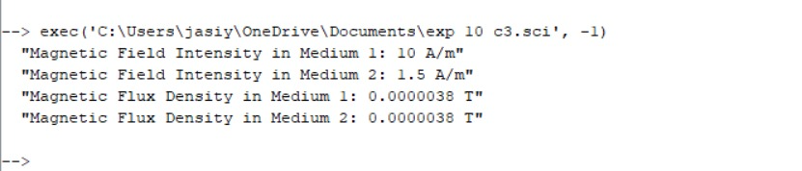

Result : Thus the effect of two different media on the magnetic field and flux density across the boundary is calculated.ssd

